1. A screenshot of a computer

   Description automatically generated
2. 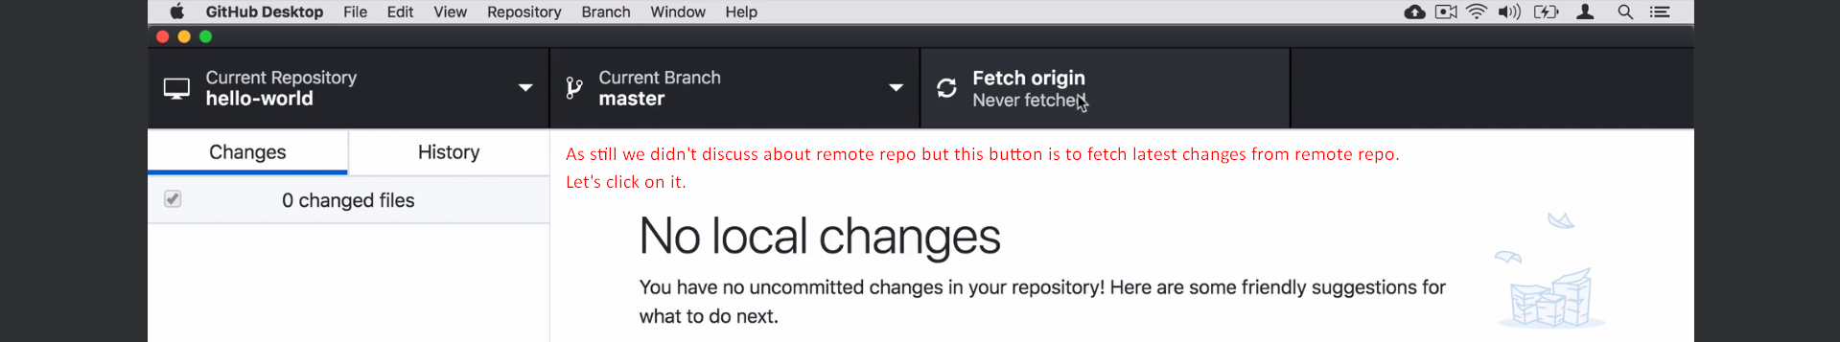
3. 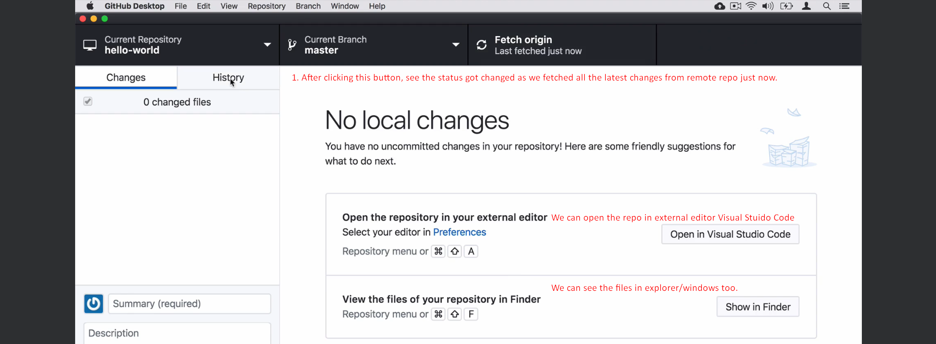
4. A screenshot of a computer

   Description automatically generated
5. A screenshot of a computer

   Description automatically generated